Lab-7
1 Create Student class in namespace CDAC namespace .
// Create another Student class in IACSD namespace.
// Try to access both student classes using namespace
#include<iostream>
using namespace std;
namespace DAC{
class Student
{

private: int rollNo;
public :
Student()
{
rollNo=1;
}
void display()
{
cout<<"student detail of DAC:"<<rollNo<<endl;
}
};
}
namespace IACSD{
class Student
{
private : int rollno;
public : Student()
{
rollno = 2;
}
void display()
{
cout<<"Student detail of IACSD:"<<rollno<<endl;
}

};
}

int main()
{
DAC::Student s1;
s1.display();

IACSD :: Student s2;
s2.display();
return 0;
}

Output:
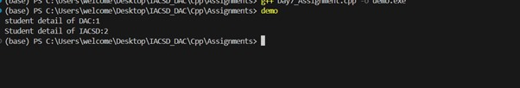

2:Create an application for storing user information in vector.
(Hint:User class with data member userid,name,email,pwd)
Create Menu Driven app
1:add user
2:display all users
3:search user
4:change pwd
5:delete all

#include<iostream>
#include<vector>
using namespace std;

class User{
private: int id; string name; string email; int pwd;

public:
User(){
id = 0;
name = "unknown";
email = "unknown";
pwd = 0000;
}
User(int id, string name, string email, int pwd){
this->id = id;
this->name = name;
this->email = email;
this->pwd = pwd;
}

void display(){
cout<<"User id = "<<id<<endl;
cout<<"name = "<<name<<endl;
cout<<"email = "<<email<<endl;
cout<<"password = "<<pwd<<endl;
cout<<"\n\n\n\n"<<endl;
}

int getid(int id){
return this->id;
}
string getname(string name){
return this->name;
}
string getemail(string email){
return this->email;
}
int getpwd(int pwd){
return this->pwd;
}

void setpwd(int pwd){
this->pwd = pwd;
}

};

int main(){

vector<User> usr;
int id,pwd;
string name,email;

User *newUsr;

int ch;

do
{
cout<<"\t\t\tEnter choice:\n1.Add user\n2.Display all user\n3.Search User\n4.Change pwd.\n5.Delete all.\n6.Exit\n\n";
cin>>ch;
switch (ch)
{
case 1:
cout<<"Enter id = "<<endl;
cin>>id;
cout<<"Enter name = "<<endl;
cin>>name;
cout<<"Enter email = "<<endl;
cin>>email;
cout<<"Enter pwd = "<<endl;
cin>>pwd;
newUsr = new User(id,name,email,pwd);
usr.push_back(*newUsr);
cout<<"Added\n\n"<<endl;
break;
case 2:
for(User u:usr){
u.display();
}
break;

case 3:
cout<<"Enter name to search = "<<endl;
cin>>name;
for(User u:usr){
if(u.getname(name) == name){
u.display();
}
}
break;

case 4:
cout<<"Enter id to change pwd = "<<endl;
cin>>id;
for(User u:usr){
if(u.getid(id) == id){
cout<<"Enter new pwd = "<<endl;
cin>>pwd;
u.setpwd(pwd);
cout<<"Password changed\n\n"<<endl;
}
}
break;

case 5:
usr.clear();
cout<<"All users deleted\n\n"<<endl;
break;

case 6:
cout<<"Exit"<<endl;
break;

default:
break;
}
} while (ch!=6);

return 0;
}

Output:

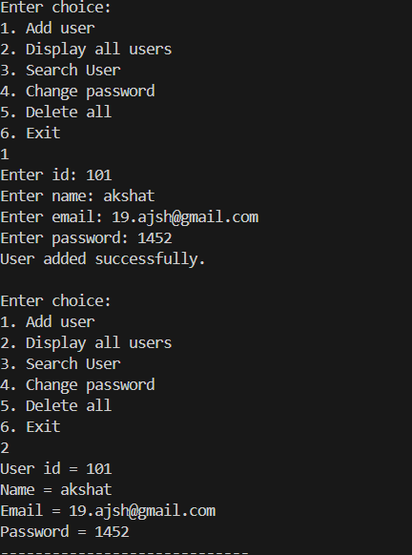
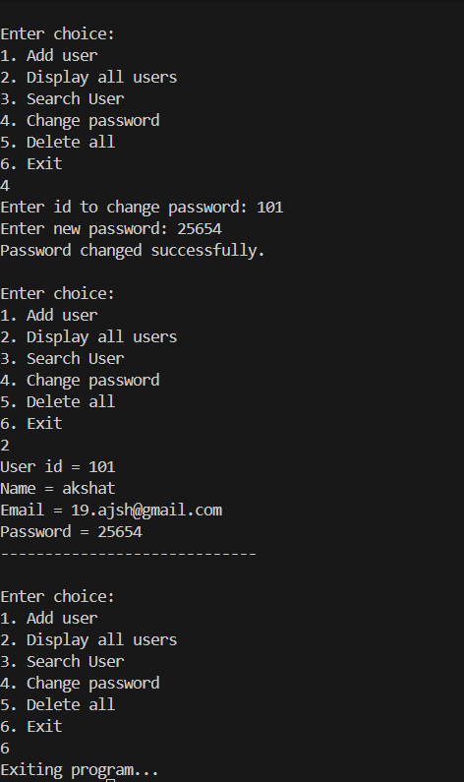
3:Create an application using set .
Accept name of city from user and store in set
Create Menu drivien app
1:add city
2:display all city
3: serach city

#include<iostream>
#include<set>
using namespace std;

int main(){
set<string> citySet;
string city;
string findCity;
bool flag=false;

cout<<"1.Add city\n2.Display\n3.Search\n4.Exit"<<endl;
int ch;

do
{
cout<<"Enter choice: "<<endl;
cin>>ch;
switch(ch)
{
case 1:

cout<<"Enter city: ";
cin>>city;
//add
citySet.insert(city);
break;

case 2:
//display
for(auto i: citySet){
cout<<i<<" "<<endl;
}
break;

case 3:
//search

cout<<"Enter city to search: "<<endl;
cin>>findCity;
flag=false;
for(string s : citySet)
{
if(findCity==s)
{ flag=true;
cout<<"found"<<endl;
break;
}
}
if(flag==false)
{
cout<<"not found"<<endl;
}

break;

case 4:
cout<<"Exit"<<endl;
break;

default:
cout<<"invalid cjoice"<<endl;
}
} while (ch!=4);

return 0;
}

Output:
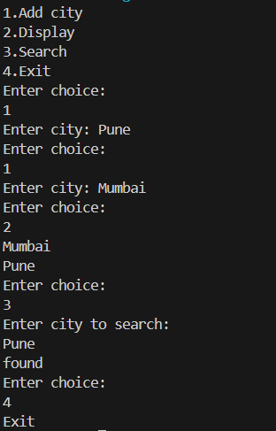

4:Create an application using map for storing key and value
key:int
value:Account type
Create Account class with actid ,name,balance
Create Menu driven app
1:Add Account
2:Display all
3:Search account by actid;
4:Remove all

#include<iostream>
#include<map>
using namespace std;

class Account{
private:
int actid;
string name;
double balance;

public:
Account(){
actid = 0;
name = "xyz";
balance = 0.0;
}

Account(int id, string name, double balance):
actid(id),name(name),balance(balance){}

void display(){
cout<<"Account id: "<<actid<<endl;
cout<<"Name: "<<name<<endl;
cout<<"Balance: "<<balance<<endl;
}
};

int main(){
map<int, Account> accMap;
int ch;
cout<<"Enter choice: "<<endl;
cout << "\n===== Menu =====" << endl;
cout << "1. Add Account" << endl;
cout << "2. Display All Accounts" << endl;
cout << "3. Search Account by ID" << endl;
cout << "4. Remove All Accounts" << endl;
cout << "5. Exit" << endl;

do
{
cin>>ch;
if (ch==1)
{
int id;
string name;
double balance;

cout<<"Enter id: "<<endl;
cin>>id;
cout<<"Enter name: "<<endl;
cin>>name;
cout<<"Enter balance: "<<endl;
cin>>balance;

accMap.insert({id, Account(id, name, balance)});
}else if(ch == 2){
if (accMap.empty()) {
cout << "No accounts available." << endl;
}else {
for (auto &p : accMap) {
p.second.display();
}
}
}else if(ch == 3){
int searchid;
cout<<"Enter id to search";
cin>>searchid;
auto it = accMap.find(searchid);
if(it != accMap.end()){
it->second.display();
}else{
cout<<"not found"<<endl;
}
}else if (ch == 4) {
accMap.clear();
cout << "All accounts removed successfully." << endl;

} else if (ch == 5) {
cout << "Exiting..." << endl;

} else {
cout << "Invalid choice. Try again!" << endl;
}
} while (ch!=5);

return 0;
}

Output:

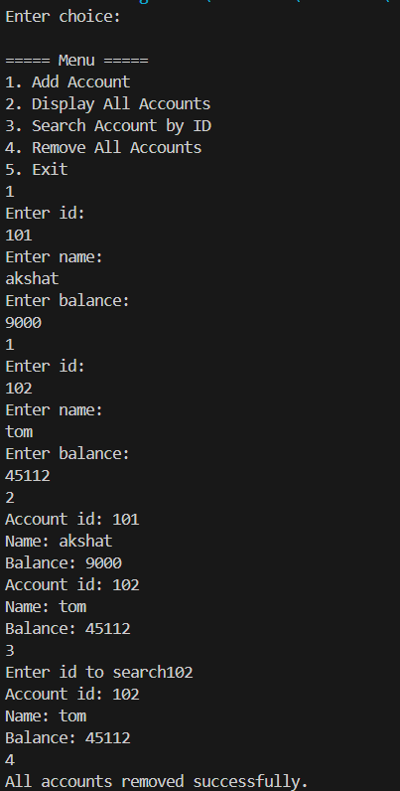
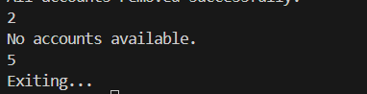

5: Create an File IO application for basic operation
1:Write file:accept data from user and store in file
2:Read file:display line by line
3:copy data from one file into another file

#include<iostream>
#include<fstream>
using namespace std;

void writeFile(){
cout<<"Writing in file"<<endl;
string filename = "myFile.txt";
ofstream outfile(filename, ios::app);
cout<<"enter name of user:"<<endl;
string name;
cin>>name;
outfile<<name<<endl;

outfile.close();
}

void readFile(){
cout<<"read data from file"<<endl;
string filename = "myFile.txt";

ifstream inputfile(filename);
string line;
if(inputfile.fail()){
cout<<"file not found!"<<endl;
}else{
cout<<"read from file"<<endl;

while(getline(inputfile, line)){
cout<<line<<endl;
}
}

inputfile.close();
}

void copyFile(){
cout << "Copying data from one file into another" << endl;
string sourceFile = "myFile.txt";
string destFile = "copyFile.txt";

ifstream src(sourceFile);
ofstream dest(destFile);

if(src && dest){
string line;
while(getline(src, line)){
dest << line << "\n";
}
cout << "Copy Finished" << endl;
} else {
cout << "Error: Cannot open source or destination file!" << endl;
}
src.close();
dest.close();
}

int main(){
int ch;
do {
cout << "\n===== Menu =====" << endl;
cout << "1. Write File" << endl;
cout << "2. Read File" << endl;
cout << "3. Copy File" << endl;
cout << "0. Exit" << endl;
cout << "Enter choice: ";
cin >> ch;

switch (ch){
case 1: writeFile(); break;
case 2: readFile(); break;
case 3: copyFile(); break;
case 0: cout << "Exiting..." << endl; break;
default: cout << "Invalid choice!" << endl;
}
} while(ch != 0);

return 0;
}

Output
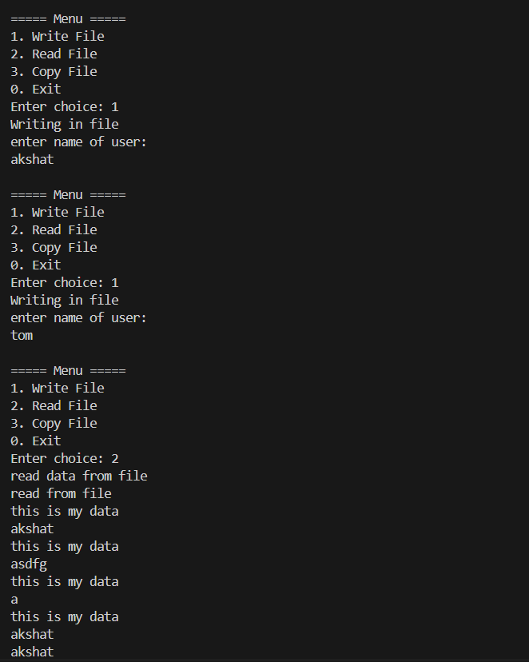
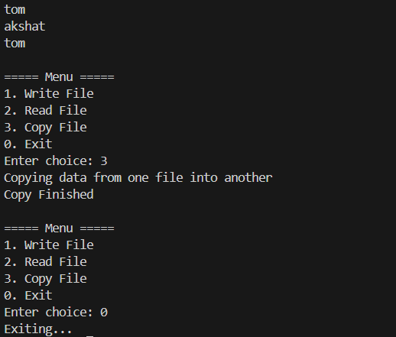

6: Create CRUD Shop Application Using File
Write class Product with data member prdid,name,qty,price;
Menus:
1:Add Prd
2:Display Prds
3:Search Prd
4:Update/Modify prd
5:delete prd

#include <iostream>
#include <fstream>
#include <string>
#include <cstring>
using namespace std;

class Product {
private:
int prdid;
char name[30];
int qty;
double price;

public:
Product() {
prdid = 0;
qty = 0;
price = 0.0;
strcpy(name, "NA");
}

void input() {
cout << "Enter Product ID: ";
cin >> prdid;
cout << "Enter Product Name: ";
cin >> name;
cout << "Enter Quantity: ";
cin >> qty;
cout << "Enter Price: ";
cin >> price;
}

void display() const {
cout << "----------------------------------\n";
cout << "Product ID: " << prdid << endl;
cout << "Product Name: " << name << endl;
cout << "Quantity: " << qty << endl;
cout << "Price: " << price << endl;
}

int getId() const { return prdid; }
};

// Add Product
void addProduct() {
Product p;
p.input();
ofstream fout("product.dat", ios::binary | ios::app);
fout.write((char*)&p, sizeof(Product));
fout.close();
cout << "Product added successfully!\n";
}

// Display Products
void displayProducts() {
ifstream fin("product.dat", ios::binary);
if (!fin) {
cout << "No records found!\n";
return;
}
Product p;
while (fin.read((char*)&p, sizeof(Product))) {
p.display();
}
fin.close();
}

// Search Product by ID
void searchProduct(int id) {
ifstream fin("product.dat", ios::binary);
Product p;
bool found = false;
while (fin.read((char*)&p, sizeof(Product))) {
if (p.getId() == id) {
p.display();
found = true;
break;
}
}
fin.close();
if (!found) cout << "Product not found!\n";
}

// Update Product by ID
void updateProduct(int id) {
fstream fio("product.dat", ios::binary | ios::in | ios::out);
Product p;
bool found = false;
while (fio.read((char*)&p, sizeof(Product))) {
if (p.getId() == id) {
cout << "Old details:\n";
p.display();

cout << "\nEnter new details:\n";
p.input();

long pos = -1 * (long)sizeof(Product);
fio.seekp(pos, ios::cur);
fio.write((char*)&p, sizeof(Product));
cout << "Product updated successfully!\n";
found = true;
break;
}
}
fio.close();
if (!found) cout << "Product not found!\n";
}

// Delete Product by ID
void deleteProduct(int id) {
ifstream fin("product.dat", ios::binary);
ofstream fout("temp.dat", ios::binary);

Product p;
bool found = false;
while (fin.read((char*)&p, sizeof(Product))) {
if (p.getId() != id) {
fout.write((char*)&p, sizeof(Product));
} else {
found = true;
}
}
fin.close();
fout.close();

remove("product.dat");
rename("temp.dat", "product.dat");

if (found) cout << "Product deleted successfully!\n";
else cout << "Product not found!\n";
}

int main() {
int choice, id;

do {
cout << "\n===== Shop CRUD Application =====\n";
cout << "1. Add Product\n";
cout << "2. Display Products\n";
cout << "3. Search Product\n";
cout << "4. Update Product\n";
cout << "5. Delete Product\n";
cout << "6. Exit\n";
cout << "Enter choice: ";
cin >> choice;

switch (choice) {
case 1: addProduct(); break;
case 2: displayProducts(); break;
case 3:
cout << "Enter product ID to search: ";
cin >> id;
searchProduct(id);
break;
case 4:
cout << "Enter product ID to update: ";
cin >> id;
updateProduct(id);
break;
case 5:
cout << "Enter product ID to delete: ";
cin >> id;
deleteProduct(id);
break;
case 6: cout << "Exiting...\n"; break;
default: cout << "Invalid choice!\n";
}
} while (choice != 6);

return 0;
}

Output
